SPRING 2025 CRS 287

Foundations of Inquiry in Human Communication

LECTURE SYLLABUS - Tue & Thurs 12:30-1:25pm

|  |  |
| --- | --- |
| **Instructor** | **Dr. Sylvia Sierra, Ph.D. (she/hers)** |
| **Office Hours** | by appointment (email me 3 or 4 options and your preference for zoom or in person) |
| **TA Office** | Sims 137 |

Required Texts:

There is no textbook required for this course. All necessary materials will be presented in lecture.

General Description:

Introduction to the various issues, arguments, positions, and concerns that frame the research methods and techniques that guide the study of human communication.

Learning Outcomes:

After taking this course, the students will be able to:

1. Adequately discuss various research methodologies used in Communication Studies.

2. Critically, comparatively, and productively evaluate theory, research methods, and scholarship in Communication Studies.

3. Produce written works about/using the different methods used in Communication Research.

4. Adequately discuss how the various methods make claims, support their arguments, and contribute to what we know about human communication.

5. Demonstrate improved academic reading, writing, and critical thinking skills.

Approach to the Course:

Learning how to frame questions, research issues and develop answers may be the key to your future success. Future CRS courses will expect you to understand, analyze, and engage in research activities. CRS 287 is designed to give you the tools to successfully complete upper-level CRS courses.

But, beyond your undergraduate career, understanding how research is done will be invaluable for you. Whatever career you enter, you will undoubtedly make decisions based on the results from some of the research methods examined in this course. You will also encounter research findings circulating in political and civic life. This course will help you understand how to evaluate research claims and make up your own mind.

Policies: Please note: these policies are for the lecture component of the course. Recitation sections are entitled to have their own individual set of policies. Students are responsible for both sets of policies and requirements.

LECTURE Attendance: Punctual and consistent attendance in lecture is expected. You must be present in both mind and body. This means you are physically present, from the start to end of class, and do not leave the classroom for extended lengths of time. This also means you are present mentally, and not engaged in other unrelated activities during lecture. All midterm and final exam questions will be based on what happens in lecture, and therefore reviewing lecture slides will not necessarily fill you in on what will be on the exams. This is meant to encourage you to come to class. If you have an accommodation to record lectures, this accommodation is for your benefit only and must not be shared with anyone or anywhere outside of the class. If you are randomly going to be absent/miss class, I request that you DO NOT email me about it with an excuse. In my classes there are no excused or unexcused absences—you are simply absent. Two absences will be dropped from your lecture attendance grade regardless of reason for absence.In the case of an unavoidable absence, it is your responsibility to keep up with coursework, get notes from classmates, etc.

Classroom conduct: Arrive on time and prepared to engage with the material and other people in a respectful manner. Do not engage in disruptive behavior such as chatting during a lecture. **Cell phones, laptops, and other electronic devices are discouraged (except with an official accommodation and/or in cases of special permission from the instructor) in an effort to facilitate classroom interaction**. If you have an accommodation or permission, use of the internet is still discouraged. Turn your wi-fi off.

Disruptive behavior during lecture (loud talking, excessive or inappropriate use of electronic devices, etc.) may result in deduction of attendance points and/or the student being asked to leave. If disruptive behavior continues, students may receive additional grade penalties up to and including failure for the course.

Exams are closed book/closed notes and are given during the lecture period, in the classroom. Exams cannot be made up after the fact without a university-approved excuse. Please see your TA (beforehand, if possible) about such excused absences. If you have an accommodation for extra time, you must speak to your TA and register that accommodation at least 48 hours in advance of the scheduled exam time.

Email: CRS 287 is modeled on real professional practice. Therefore, we expect professional behavior and engagement with your peers and with the TAs. Any instance of abusive language or behavior (by email or in-person) may accrue a grade penalty and be submitted to judicial review by the University. Send emails from your syr.edu account. **The message subject line should include our course number, section, and your reason for emailing (e.g., CRS 287 section 1: Midterm Exam question).** If you do not follow these requirements, you might not receive a response.

Use of Student Work: As per university policy (see Appendices at end of this syllabus), your work in 287 may be used for educational purposes.

Letters of reference/recommendation: I will consider writing letters of recommendation for students who have taken at least 2 classes with me. For me to be able to write you one, you need to make yourself known to me as an individual. You also need to ensure that you provide me with the deadline of your letter upon requesting it and that you make the request with enough time for me to write it.

**Grading**

Lectures will include a midterm exam and a cumulative final exam; see the schedule.

**Lecture Attendance/Participation** – 10%

**Recitation Attendance/Participation** – 10%

**TA lecture assignment** – 20%

**TA lecture assignment**– 20%

**TA lecture assignment**– 20%

**Midterm Exam** – 50%

**Lecture Reflection** – 20%

**Final Exam**– 50%

**Grades are earned – they are not subject to negotiation. I do not provide “extra credit”. It is your responsibility to keep up with assignments and to monitor your progress as well as grades on Blackboard.**

Grading Issues: All assignments will be graded by the instructor of your recitation section. Any concerns or questions must be brought to the recitation instructor first. In the event that the concern cannot be resolved, students may bring concerns to the lecture instructor (Dr. Sierra).

Any grade questions or disputes must be raised after 24 hours but within one week of the posting of the grade. After one week, grades are final. Students missing assignments with approved excuses are responsible for making arrangements to make up the work. Students are responsible for all assignments in both lecture and recitation.

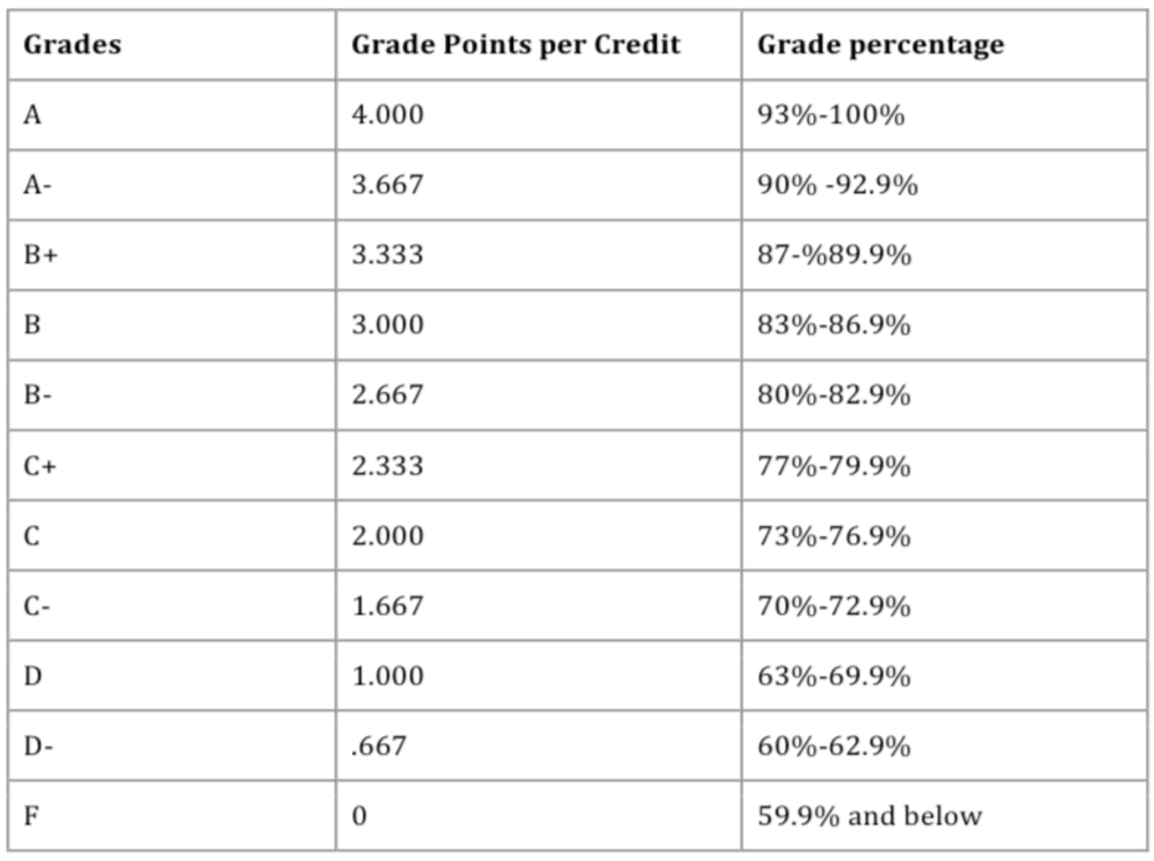

**Note on the Schedule:** Our schedule is tentative. I will do my best to keep the exam dates stable (though, please recognize that there are many external factors that can impact our semester). However, as we rely on many SU offices and guest speakers to connect with our class, there may be some shifting of content days to accommodate these guests. I ask for your patience and understanding.

Schedule of Lectures (Tuesday/Thursday)

|  |  |  |  |  |
| --- | --- | --- | --- | --- |
| **Wk** | **TUES** | **TUES Topic** | **THUR** | **THURS Topic** |
| 1 | 1/14 | Introduction | 1/16 | Academic Integrity |
| 2 | 1/21 | Evaluating & citing sources | 1/23 | Undergraduate Research at SU |
| 3 | 1/28 | Undergraduate CRS Research | 1/30 | Library Research |
| 4 | 2/4 | Ethics in human subject research | 2/6 | Ethics in human subject research |
| 5 | 2/11 | Ethnography | 2/13 | Discourse Analysis & Conversation Analysis |
| 6 | 2/18 | Discourse Analysis & Conversation Analysis | 2/20 | TBA |
| 7 | 2/25 | Visual Performance | 2/27 | Midterm exam review session online via Zoom meeting |
| 8 | 3/4 | **Midterm Exam in person** | 3/6 | Field work |

**SPRING BREAK**

|  |  |  |  |  |
| --- | --- | --- | --- | --- |
| 9 | 3/18 | Media Studies | 3/20 | Rhetorical Studies |
| 10 | 3/25 | Qualitative sociolinguistic methods part 1 | 3/27 | Qualitative sociolinguistic methods part 2 |
| 11 | 4/1 | Sociolinguistic Variation and Corpus Linguistics | 4/3 | Second language acquisition |
| 12 | 4/8 | Field work/methods | 4/10 | Computational linguistics |
| 13 | 4/15 | CRS Alumni Research at work | 4/17 | CRS Alumni Research at work |
| 14 | 4/22 | Final exam review session online via Zoom meeting | 4/24 | **Final Exam in person** & course evals |

**Mental health and wellness considerations:**

**Mental health and overall well-being are significant predictors of academic success. As such it is essential that during your college experience you develop the skills and resources to effectively navigate stress, anxiety, depression and other mental health concerns. Please familiarize yourself with the range of resources the Barnes Center provides (https://ese.syr.edu/bewell/) and seek out support for mental health concerns as needed. Counseling services are available 24/7, 365 days, at 315-443-8000. I encourage you to explore the resources available through the Wellness Leadership Institute, https://ese.syr.edu/bewell/wellness-leadership-institute/.”**

**Hunger and food scarcity at SU:**

**There are food pantries at both Hendricks Chapel and on South Campus, stocked with edibles and personal care items. To find out more, go to the Hendricks Food Pantry Site, or contact Syeisha Bird at smbyrd@syr.edu, or at 315-706-4526. There may be other food resources; reach out if you need help finding them.**

**University Policies**

**Academic Integrity**

Syracuse University’s [Academic Integrity Policy](https://class.syr.edu/academic-integrity/policy/) reflects the high value that we, as a university community, place on honesty in academic work. The policy holds students accountable for the integrity of all work they submit and for upholding course-specific, as well as university-wide, academic integrity expectations. The policy governs citation and use of sources, the integrity of work submitted in exams and assignments, and truthfulness in all academic matters, including course attendance and participation. The policy states that any work a student submits for a course must be solely their own unless the instructor explicitly allows collaboration or editing. The policy also requires students to acknowledge their use of other peoples’ language, images or other original creative or scholarly work through appropriate citation. These expectations extend to the new, fast-growing realm of artificial intelligence (AI) as well as to the use of websites that charge fees or require uploading of course materials to obtain exam solutions or assignments. Students are required to ask their instructor whether use of these tools is permitted – and if so, to what extent – before using them to complete any assignment or exam. Students are also required to seek advance permission from instructors if they wish to submit the same work in more than one course. Failure to receive this permission in advance may violate the Academic Integrity Policy. Under the policy, instructors who seek to penalize a student for a suspected violation must first report the violation to the Center for Learning and Student Success (CLASS). Students may not drop or withdraw from courses in which they face a suspected violation. Instructors must wait to assign a final course grade until a suspected violation is reviewed and upheld or overturned. Upholding Academic Integrity includes abiding by instructors’ individual course expectations, which may include the protection of their intellectual property. Students should not upload, distribute, or otherwise share instructors’ course materials without permission. Students found in violation of the policy are subject to grade sanctions determined by the course instructor and non-grade sanctions determined by the School or College where the course is offered, as outlined in the Violation and Sanction Classification Rubric. Students are required to read an online summary of the University’s academic integrity expectations and provide an electronic signature agreeing to abide by them twice a year during pre-term check-in on MySlice.

The Violation and Sanction Classification Rubric establishes recommended guidelines for the determination of grade penalties by faculty and instructors, while also giving them discretion to select the grade penalty they believe most suitable, including course failure, regardless of violation level. Any established violation in this course may result in course failure regardless of violation level.

Using websites that charge fees or require uploading of course material (e.g., Chegg, Course Hero) to obtain exam solutions or assignments completed by others and present the work as your own violates academic integrity expectations in this course and may be classified as a Level 3 violation, resulting in suspension or expulsion from Syracuse University.

For more information about the policy, see <https://class.syr.edu/academic-integrity/>. If you have any questions about academic integrity, proper citation of sources, inappropriate collaboration, and so on, please communicate with me about it.

**BLACKBOARD LEARNING MANAGEMENT SYSTEM**

This class will use the Blackboard Learning Management to house the syllabus, course content, links to external course materials, assignments, quizzes, exams, feedback, and grades. Note when submitting materials that the University’s Blackboard Learning Management System is on Eastern Time.

If students are unable to submit an assignment due to Blackboard issues, **they must submit a screenshot of the error message and/or a ticket for a request for ITS support as documentation.**

Information about Blackboard is available on[Answers Blackboard](https://answers.syr.edu/display/blackboard01/Blackboard#space-menu-link-content); alternatively, you can contact Information Technology Services by sending an email to[help@syr.edu,](mailto:help@syr.edu) calling 315.443.2677, or in-person at the ITS Service Center, located at 1-227 CST in the Life Sciences Complex. Out of an abundance of caution, the ITS Service Center may be open on an appointment-only basis.

**ACADEMIC ACCOMMODATIONS FOR STUDENTS WITH DISABILITIES:**

Syracuse University values diversity and inclusion; we are committed to a climate of mutual respect and full participation.  There may be aspects of the instruction or design of this course that result in barriers to your inclusion and full participation in this course.  I invite any student to contact me to discuss strategies and/or accommodations (academic adjustments) that may be essential to your success and to collaborate with the Center for Disability Resources (CDR) in this process. If you would like to discuss disability-accommodations or register with CDR, please visit [Center for Disability Resources](https://disabilityservices.syr.edu/). Please call (315) 443-4498 or email [disabilityresources@syr.edu](mailto:disabilityresources@syr.edu) for more detailed information. The CDR is responsible for coordinating disability-related academic accommodations and will work with the student to develop an access plan. Since academic accommodations may require early planning and generally are not provided retroactively, please contact CDR as soon as possible to begin this process.

**DISCRIMINATION OR HARASSMENT**

The University prohibits harassment or discrimination related to any protected category including creed, ethnicity, citizenship, sexual orientation, national origin, sex, gender, pregnancy, disability, marital status, age, race, color, veteran status, military status, religion, sexual orientation, domestic violence status, genetic information, gender identity, gender expression or perceived gender. Any complaint of discrimination or harassment related to any of these protected bases should be reported to Sheila Johnson-Willis, the University’s Chief Equal Opportunity & Title IX Officer. She is responsible for coordinating compliance efforts under various laws including Titles VI, VII, IX and Section 504 of the Rehabilitation Act. She can be contacted at Equal Opportunity, Inclusion, and Resolution Services, 005 Steele Hall, Syracuse University, Syracuse, NY 13244-1120; by email: titleix@syr.edu; or by telephone: 315-443-0211. Federal and state law, and University policy prohibit discrimination and harassment based on sex or gender (including sexual harassment, sexual assault, domestic/dating violence, stalking, sexual exploitation, and retaliation). If a student has been harassed or assaulted, they can obtain confidential counseling support, 24-hours a day, 7 days a week, from the Sexual and Relationship Violence Response Team at the Counseling Center (315-443-8000, Barnes Center at The Arch, 150 Sims Drive, Syracuse, New York 13244). Incidents of sexual violence or harassment can be reported non-confidentially to the University’s Title IX Officer (Sheila Johnson Willis, 315-443-0211, titleix@syr.edu, 005 Steele Hall). Reports to law enforcement can be made to the University’s Department of Public Safety (315-443-2224, 005 Sims Hall), the Syracuse Police Department (511 South State Street, Syracuse, New York, 911 in case of emergency or 315-435-3016 to speak with the Abused Persons Unit), or the State Police (844-845-7269). I will seek to keep information you share with me private to the greatest extent possible, but as a professor I have mandatory reporting responsibilities to share information regarding sexual misconduct, harassment, and crimes I learn about with the University’s Title IX Officer to help make our campus a safer place for all.

**FAITH TRADITION OBSERVANCES**

Syracuse University recognizes the diversity of faiths represented in the campus community and protects the rights of students, faculty, and staff to observe religious holy days according to their traditions. Under the policy, students should have an opportunity to make up any examination, study, or work requirements that may be missed due to a religious observance provided they notify their instructors no later than the end of the second week of classes for regular session classes and by the submission deadline for flexibility formatted classes. Student deadlines are posted in MySlice under Student Services/Enrollment/My Religious Observances/Add a Notification.

**THE FAMILY EDUCATIONAL RIGHTS AND PRIVACY ACT**

The Family Educational Rights and Privacy Act (FERPA) sets forth requirements regarding the privacy of student records. FERPA governs both the access to and release of those records, known as education records, and the information they contain. Under FERPA, faculty have a legal responsibility to protect the confidentiality of student records. For additional information about FERPA and Syracuse University’s FERPA policy, see [Compliance with the Family Education Rights and Privacy Act](https://policies.syr.edu/policies/university-governance-ethics-integrity-and-legal-compliance/compliance-with-the-family-educational-rights-and-privacy-act-ferpa/) or contact the Office of the Registrar (315.443.3535).

In recent years it has become increasingly common for parents and other family members to contact faculty directly with questions about a student’s academic performance. If this happens, you are encouraged to consult your department chair or senior associate dean for guidance. Even seemingly innocuous statements about matters such as class attendance or participation can constitute FERPA violations. Students may file FERPA waiver forms, which allow university personnel to discuss their academic records and performance with specified individuals.

**ORANGE ALERT**

ORANGE ALERT, Syracuse University’s crisis notification system, uses text messages, phone, and email alerts to provide rapid notification and instructions to members of the University community in the event of a crisis in progress.

**In the event of an emergency, please use one of the following numbers to reach us:**

From any phone: 315.443.2222  
From your cell phone: #78 (#SU)  
Campus landline: 711  
For more information on ORANGE ALERT, including how to update your contact information, visit the [DPS website](https://dps.syr.edu/public-information/orange-alert/)

**EMAIL POLICY**

Syracuse University has established email as a primary vehicle for official communication with students, faculty, and staff. Emergency notifications, educational dialog, research, and general business correspondence are all consistently enhanced in institutions of higher learning where email policies exist and are supported by procedures, practice, and culture.

An official email address is established and assigned by Information Technology Services (ITS) for each registered student, as well as for all active faculty and staff members. All University communications sent via email will be sent to this address. Faculty and staff members must use the officially established University email address to communicate with students registered in their classes. Keep in mind that student records sent to a non-syr.edu email address may create a FERPA violation (See the complete policy at [Syracuse University Email Policy](https://policies.syr.edu/policies/information-technology/e-mail-policy/)).

**TRIGGER WARNING**

Because of the nature of the topics covered in this class, the course readings or class discussions may generate intellectual and emotional discomfort. These responses are natural parts of intellectual growth. If, however, your emotional response becomes acute psychological distress (triggering), please communicate with me. I invite you to contact me if you have concerns in this regard.